PROBLEM STATEMENT
Basically, the problem is all about personalised treatment regarding personalised treatment for cancer through genetic testing. Genetic map is unique for every individual. Mutations in genes leads to cancer. So our problem in precise is all about classifying clinically actionable mutations that led predefined treatment for cancer. Challenge lies in distinguishing mutilations that contribute to cancer growth. Currently this interpretation of genetic mutations is being done manually. This is a very time-consuming task where a clinical pathologist has to manually review and classify every single genetic mutation based on evidence from text-based clinical literature.
HYPOTHESIS GENERATION
Every individual is unique in nature their body structure and all.so each every one has different genetic makeup. Cancer is all about abnormal proliferation of cells due to mutation of genetic material. Generally any mutation in gene sequence may result in the variation of expressing protein which is is not normal in nature this led to have a chance for cancer may be a cancer producing gene .so we need to study the abnormal genetic mutations which gives information about type of cancer it cause and then accordingly treatment is done. Also the variation caused as a result of this genetic mutation is also to be taken into consideration for the cancer causing gene, so maximum this data will be form of text.with this this help pf these two descriptors we can classify the cancer treatment. Already doctors will keep record of this two descriptors abnormal genes and the variations that led to cancer so we can collect the data related to these two attributes in classifying. Apart from these we can get access of information related to cancer causing agents from the research institutes , scientific journals, articles and various research papers related to cancer study.so we can collect that information analyse and get more features that can explain the target variable for better classification for more precise for classification of mutations that led to cancer. Also we hear various types of cancers that were diagnosed eg blood cancer, lung cancer, throat cancer.so if we find the reasons that why this person effected with the cancer also why only that type of cancer in particular.like wise if we have information then we can predict to classify the actionable genetic mutations causing cancer for effective accuracy.
Exploratory Data Analysis(EDA)
Our main aim is to classify actionable genetic mutations that will result in precise customised treatment.treatment.If we see the data given
The data comes in 4 different files. Two csv files and two text files:
• training/test variants: These are csv catalogues of the gene mutations together with the target value Class, which is the (manually) classified assessment of the mutation. The feature variables are Gene, the specific gene where the mutation took place, and Variation, the nature of the mutation. The test data of course doesn’t have the Class values. This is what we have to predict. These two files each are linked through an ID variable to another file each, namely:
• training/test text: Those contain an extensive description of the evidence that was used (by experts) to manually label the mutation classes.
The text information holds the key to the classification problem and will have to be understood/modelled well to achieve a useful accuracy.so how much effectively we model the clinical text evidence better we reach the aim in contributing in classifying for cancer predefined treatment

ID Gene Variation Class
Min. : 0 BRCA1 : 264 Truncating Mutations: 93 1:568
1st Qu.: 830 TP53 : 163 Deletion : 74 2:452
Median :1660 EGFR : 141 Amplification : 71 3: 89
Mean :1660 PTEN : 126 Fusions : 34 4:686
3rd Qu.:2490 BRCA2 : 125 Overexpression : 6 5:242
Max. :3320 KIT : 99 G12V : 4 6:275
BRAF : 93 E17K : 3 7:953
ALK : 69 Q61H : 3 8: 19
(Other):2241 (Other) :3033 9: 37

Glimpse(train)

Observations: 3,321

Variables: 4

$ ID <dbl> 0, 1, 2, 3, 4, 5, 6, 7, 8, 9, 10, 11, 12, 13, 14, 15...

$ Gene <fctr> FAM58A, CBL, CBL, CBL, CBL, CBL, CBL, CBL, CBL, CBL...

$ Variation <fctr> Truncating Mutations, W802*, Q249E, N454D, L399V, V...

$ Class <fctr> 1, 2, 2, 3, 4, 4, 5, 1, 4, 4, 4, 4, 4, 4, 5, 4, 1, ...

Top Gene and its count in train data set
<fctr> <int>
## 1 BRCA1 264
## A tibble: 264 x 2
## Gene ct
## TP53 163
## 3 EGFR 141
## 4 PTEN 126
## 5 BRCA2 125
## 6 KIT 99
## 7 BRAF 93
## 8 ALK 69
## 9 ERBB2 69
## 10 PDGFRA 60
## # ... with 254 more rows

Top Gene and its count in Test data set

## # A tibble: 1,397 x 2
## Gene ct
## <fctr> <int>
## 1 F8 134
## 2 CFTR 57
## 3 F9 54
## 4 G6PD 46
## 5 GBA 39
## 6 AR 38
## 7 PAH 38
## 8 CASR 37
## 9 ARSA 30
## 10 BRCA1 29
## # ... with 1,387 more rows

Top variations and its count in the train data set
train %>%
## # A tibble: 5,628 x 2
## Variation ct
## <fctr> <int>
## 1 Truncating Mutations 18
## 2 Deletion 14
## 3 Amplification 8
## 4 Fusions 3
## 5 G44D 2
## 6 A101V 1
## 7 A1020P 1
## 8 A1028V 1
## 9 A1035V 1
## 10 A1038V 1
## # ... with 5,618 more rows
Findings
- There are 3321 different IDs in the training set containing 264 different Gene expressions with 2996 different Variations. There are 9 different Classes indicated by integer levels.
- The Gene and Variation features contain character strings of various lengths.
- There is 70% more test data than train data. The data description tells us that “Some of the test data is machine-generated to prevent hand labeling.”, which should explain this otherwise curious imbalance.
- There are no missing values in the variants data.
- The most frequent Genes in the train vs test data are complete different. In addition, the test data seems to contain significantly more different Genes and fewer high-frequency Genes than the train data. To some extent, this might be an effect of the added machine-generate entries in the test data (by adding many different random levels). Thereby, the difference in frequency might mirror the true fraction of effective test data over train data.
- In contrast, the most frequent Variations in train vs test are largely identical; although, again, the corresponding frequencies are lower in the test data (by a factor of 5 - 10).

Individual feature visualisations
This is the frequency distribution of the most frequent Gene values
Top gene in train data set
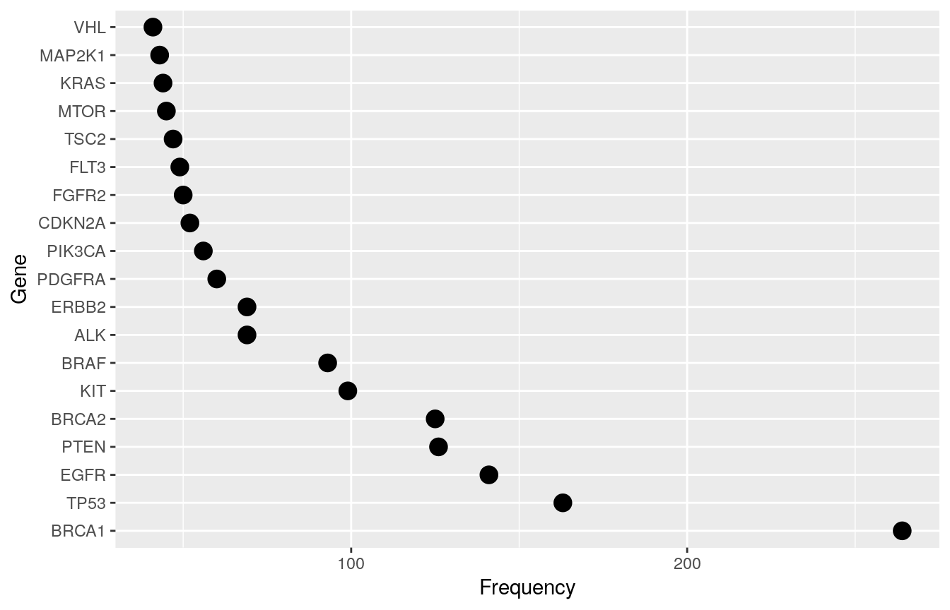
Findings
- Some Genes, like “PTEN”, are predominatly present in a single Class (here: 4).
- Other Genes, like “TP53”, are mainly shared between 2 classes (here: 1 and 4).
- Classes 8 and 9 contain none of the most frequent Genes.

Gene vs frequency in Test Data set
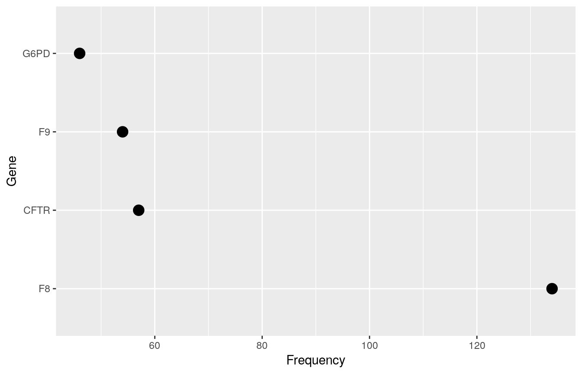

Findings
- A relatively small group of Gene levels make up a sizeable part of the feature values in both train and test data.
- The test data has fewer high-frequency Gene

Following below is the plot showing variation and its frequency of top variationsof both train and test data sets
Orange colour represents test dataset
Blue colour represents train dataset
- 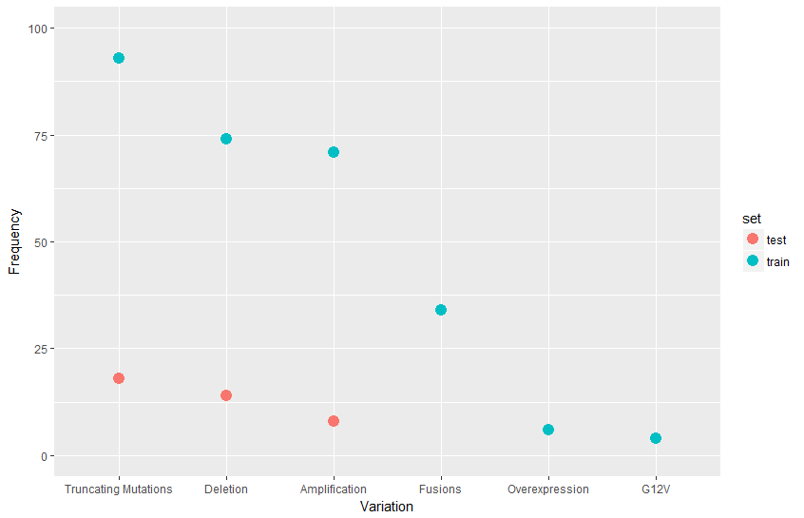

Findings:
Truncating variations, Deletion and Amplification are the top variation types in Train data when compared with Test data sets

Here we see how the Class target is distributed in the train data
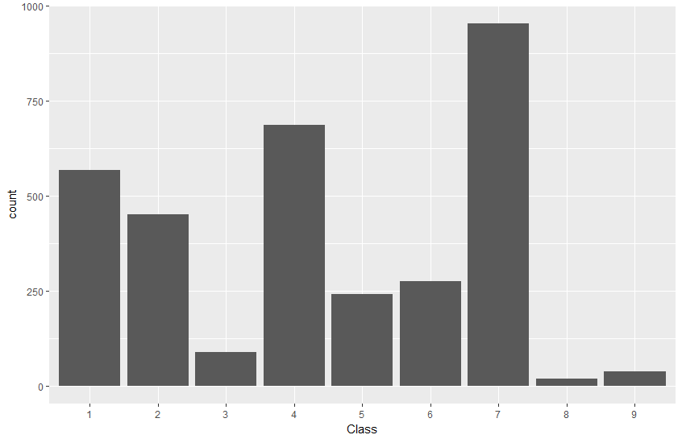

Findings
- Class levels 3, 8, and 9 are notably under-represented
- Levels 5 and 6 are of comparable, medium-low frequency
- Levels 1, 2, and 4 are of comparable, medium-high frequency
- Level 7 is clearly the most frequent one

Feature Interactions
Now we want to examine how the features interact with each other and with the target Class variable.
Gene vs Class
First, we will look at the frequency distribution of the overall most frequent Genes for the different Classes. Note the logarithmic frequency scale.
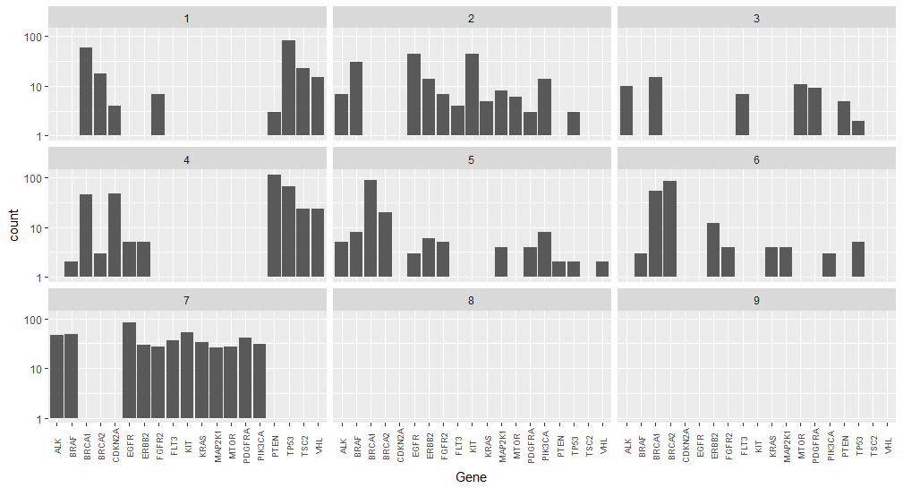

Findings
- Some Genes, like “PTEN”, are predominantly present in a single Class (here: 4).
- Other Genes, like “TP53”, are mainly shared between 2 classes (here: 1 and 4).
- Classes 8 and 9 contain none of the most frequent Genes.

Graph showing Classes sorted by Genes

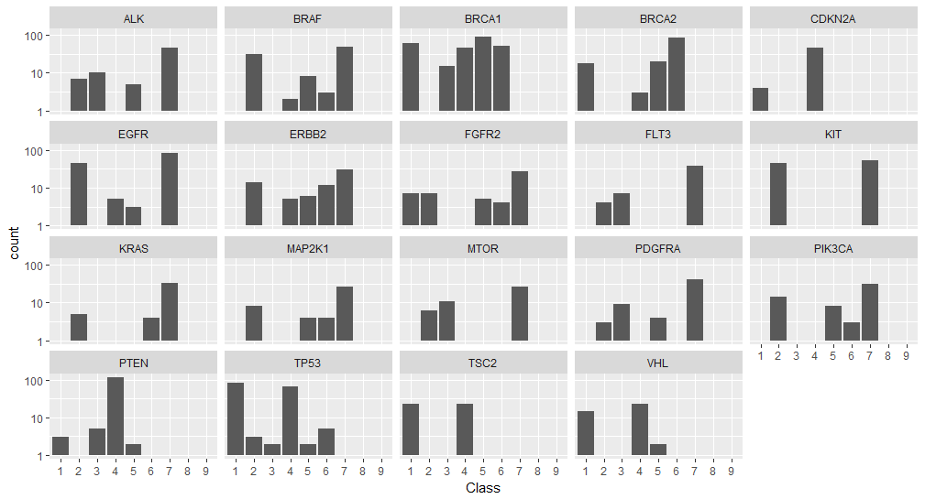
Findings
This representation underlines our findings about the similar/dominating Genes in different Classes.
Next type of data is in the form of text. Huge data in the form of text is available. The main challenge also lies in modelling the text data.Here we analyse text in the form of document term matrix .More than 10lakh terms known as variables will be there but we do a marvellous feature engineering technique called TF-IDF is used to extract best text features after doing various preprocees techniques also I had created my own stop list that would pose highly insignificant in explaining the target variable.
Stopword List
"author","describe","find","found", "result",
"conclude","analyze","analysis","show","shown","resulted","concluded","described",
"concluded","evaluate","evaluated","discuss","discussed","demonstrate","demonstrated",
"the","this","that","these","those","illustrated","illustrate","list","fig","figure",
"et","al","data","determined","studied","indicated","research","method","determine",
"studies","study","indicate","research","researcher","medical","background","abstract",
"and","but","all","also","are","been","both","can","consider","describe","described",
"declar","determin","did","rt","http\\*"

Feature Engineering
Here in order to extract best features from the text we use TF-idf a feature engineering technique .
About TF-IDF technique
TFIDF, short for term frequency–inverse document frequency, is a numerical statistic that is intended to reflect how important a word is to a document in a collection or corpus.^{[1]} It is often used as a weighting factor in searches of information retrieval, text mining, and user modeling. The tf-idf value increases proportionally to the number of times a word appears in the document, but is often offset by the frequency of the word in the corpus, which helps to adjust for the fact that some words appear more frequently in general. Nowadays, tf-idf is one of the most popular term-weighting schemes. For instance, 83% of text-based recommender systems in the domain of digital libraries use tf-idf. Text mining : To analyse the text data, we will first make it handy.
- For this purpuse the prepocessing of text data is required.
- The pre-processing should be done in the same way for train text and test text.
- Hence, the merging of both data set is required first.
- For this purpose, we will first merge variant data with text data for both and then will merge train and test.

By using TFIDF technique here on both train and text data we we extracted 2,670 best set features that could explain well about the target variable class.
Below are the top 10 highest frequency features
# A tibble: 10 x 2
name count
<chr> <dbl>
1 alk 21.50574
2 brca 40.53764
3 egfr 25.08031
4 fgfr 20.92278
5 null 19.49332
6 pten 25.57930
7 smad 28.34689
8 tsc 26.12717
9 variant 20.95599
10 vus 20.15408

Now remaining variables apart from Gene , variation are taken as factor variables and our target variable (Class ) is taken as a factor variable.
Since no data is missing, we combine these variables to build our model
Model Building
Since we are doing textual mining handling more than 2000 features as variables to predict our target variable. Taking an assumption that each and every feature is important in predicting the target variable we build our model through Naïve Bayes. Since Naïve bayes works on bayes theorem of probability taking assumption that each and every feature has good probability in predicting the variable.
So we divide the train data into train and and validation set by simple random sampling by following 80/20 rule we train 80% of our data in building the model and remaining 20% of variable is taken as validation data.so in training data set of 3321 rows we takes 2657 rows of data to build model and remaining 664 rows of data as validation set to cross validate and find accuracy of the mode
Validation of the model
Validation of the model is done through validation set
After building model with train data and then used to predict on validation set.
Following are the various evaluation metrics of the model on validation data set
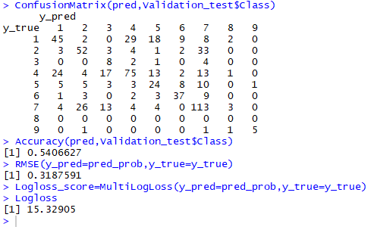
Upon seeing the metrics, the model built so far is not upto the mark in predicting the target variable but so far fair enough to learn by applying different algorithms such as random forest, Xgb or otherwise need to pre-process the data well in enhanced manner before injecting to model after all learning is a continuous process.
Output
Now by building final model with complete training dataset on the competition data set i.e on test set in better way is saved as a submission file containing prediction of classes with corresponding ID’s.

